2022 Practice Log

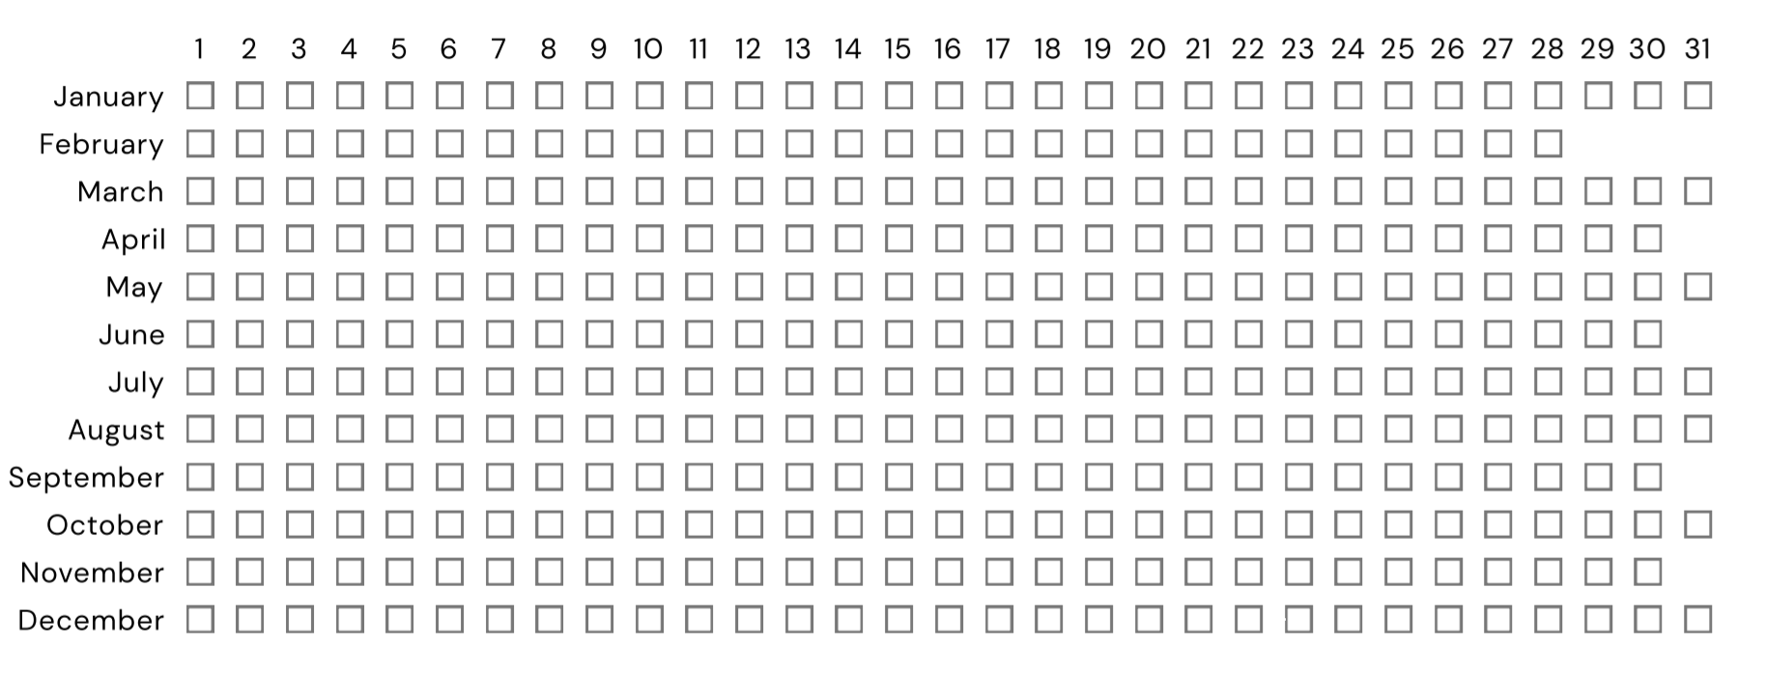

Total Hours for Entire Year: __________________
Average Hours per Month: __________________

Month with Fewest Hours: __________________
Month with Most Hours: __________________

